How to run the Project on your local machine.

1. Please download the project from GitHub. Download zip file and unzip it.

<https://github.com/isulman10/OpenClinica>

1. Please download Eclipse and install it.
2. Download the following Plugins

Open Eclipse 🡪 Help 🡪 Eclipse MarketPlace

* Cucumber Eclipse Plugins
* Natural 0.9
* TestNG for Eclipse

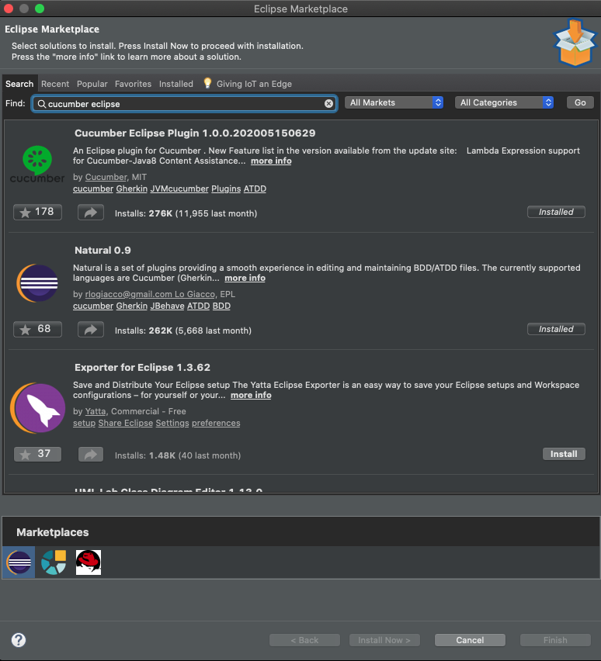

1. Please import the project in Eclipse IDE.

File 🡪 imports 🡪 search Maven 🡪Existing Maven Project 🡪 Browse 🡪 go to project

1. Now you need to Update the Project.

* Right click on the project 🡪Go to Maven tab 🡪 Update Project
* Right click on the project 🡪 Go to Configure 🡪 Convert to Cucumber Project

***How to Run your Test Cases***

1. Open Project and got src/test/java folder and go to TestRunner package and open MyTestRunner Class.
2. Right click on the class and go to RunAs and click on Junit Test

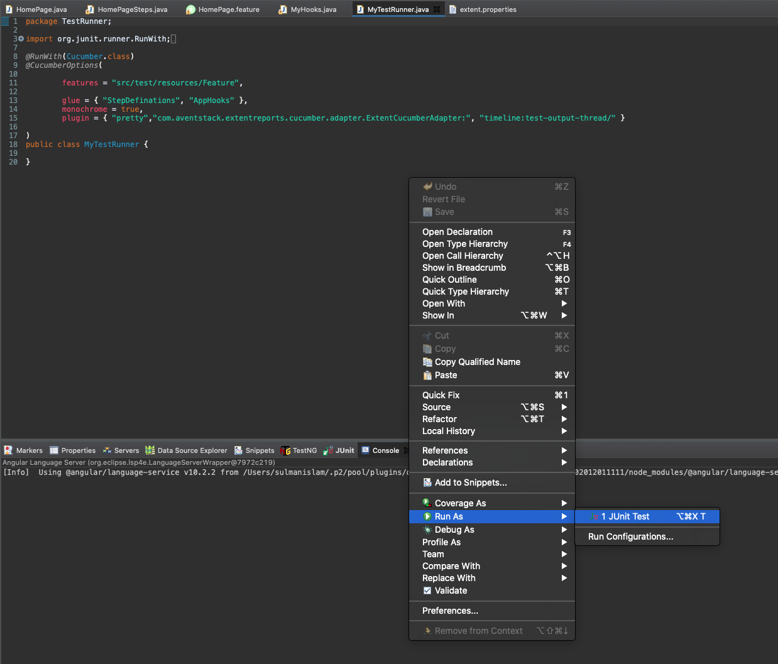

How to check the Reports After Run.

1. When the Test Case Run Successfully then you need to refresh your project.

Right click on the project 🡪 Click on the Refresh button

1. Open Test Output Folder and double click on the PDF File.
2. There is another Report Spark Reports.

